**Norwegian Polar Institute**

We carry out research, environmental monitoring and mapping, and provide environmental management advice, in the Arctic and the Antarctic.

CLIMATE BIODIVERSITY ECOTOXINS GEOLOGY

[www.npolar.no](http://www.npolar.no)

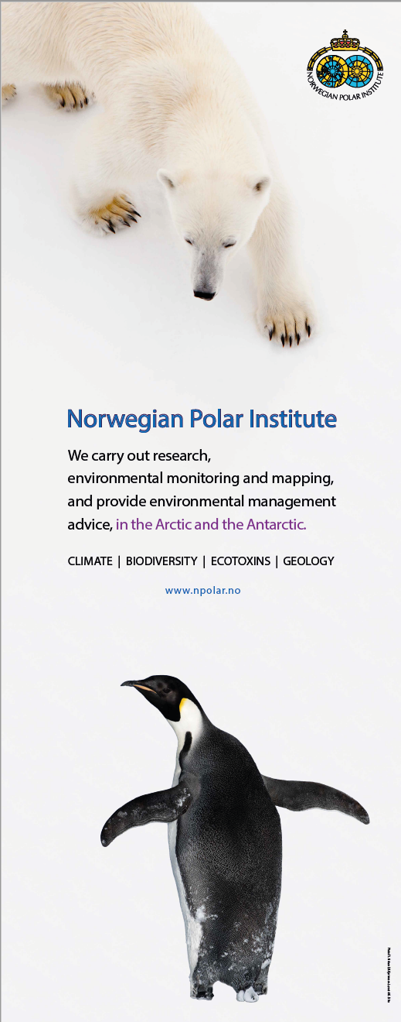 This is a roll-up we made some years ago.