Fimbulisen thermistor string - service 2025
Versjon 12/11-2025, Geir Moholdt

Purpose
To have a long-lasting (5-10 years) and low-maintenance (a few hours) way of measuring snow accumulation, melting and refreezing at sites of interest, e.g. ApRES basal melt instruments.

Preparation before fieldwork
Install software from installation file Setup_FG2_Shell_4V01.exe
This creates a folder (e.g. C:\FG2_Shell_V3\) with a program called fg2_shell.exe
Insert USB-antenna and try running the fg_2_shell.exe program to see that it works like below.

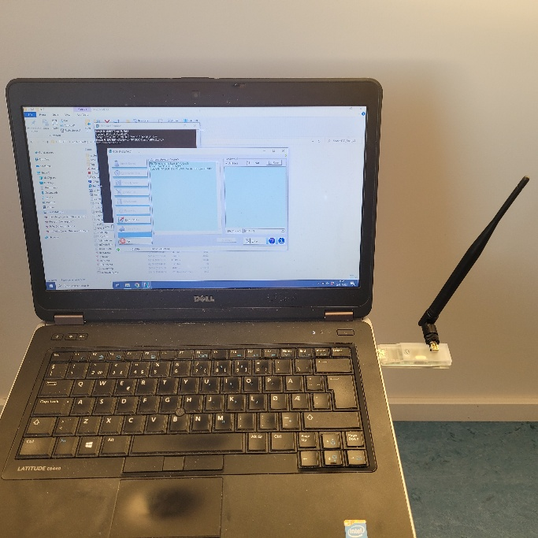

Equipment to bring
Shovel, measure tape, GPS (preferably Trimble with antenna mount for stake), el-tape, strips. Extra stake to make hole or stake-drill if icy/ hard snow. Bamboo to mark site.

Current thermistor installations
Two thermistor strings were purchased from Geoprecision and put on mass balance stakes for deployment on Fimbulisen moorings M1 and M2 in summer 2021-22. Each stake is 3 m long and has 15 loggers every 20 cm (see figure below). The thermistor string at M1 has since been moved to a new ApRES site near the loading bay and ice-shelf front. This is the one to be serviced in 2025 along with the ApRES redeployment.

Serial number and access code for the two loggers, of which one is at the ApRES site:
- Serial A53D83, acces-code D230
- Serial A53D84, acces-code 1071
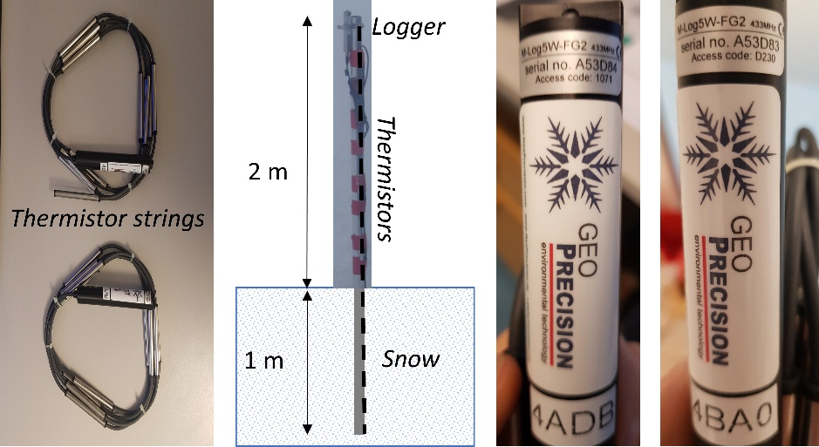

Work description
1) Data download with USB-antenna (range of a few meters, even through snow):
- Plug in USB-antenna to PC and open fg2_shell.exe
- Click «Identify Device» (give access code if needed) -> data report is written to screen
- Click «Load to disk» -> saves a csv-file with data in folder C:\FG2_Shell_V3\data
- Check that battery status and storage space is ok (delete old data only if needed for space)

2) Measure old stake: Measure the precise stake height from the snow surface to the top and take a closeup picture that shows the loggers versus the snow surface. If possible, mount a Trimble GPS on top of the stake and log for minimum 15 mins. Otherwise, write down approximate position from handheld GPS.

2) Redeployment of stake: If current stake height is <1.5 m, it should be reinstalled higher. Carefully dig out the stake and check that loggers are in place. Use tape/strips as needed to fix them better, maintaining the 20 cm spacing. Level the surface and find a suitable solid-snow location for redeployment. Use a clean stake to make a 1 m deep hole to put the thermistor stake into it. If snow is loose, you might need to go deeper to make it stable, or if the snow is very hard, a stake-drill might be needed. Consider extending the stake with bamboo to make sure it will be visible next year also (1-2 m snow accumulation?).

3) Measure new stake: Repeat step 1. Share notes, GPS-files and pictures with field report or email directly to Geir or Elin. Check list and notes:

Downloaded data file:
Stake height, old:
Stake height, new:
GPS file or position, old:
GPS file or position, new:
Pictures:

Data and contact: Geir Moholdt, moholdt@npolar.no, 99102900

